# A

PROJECT REPORT ON

**LPG Cylinders Distributor Software**

By

Devendrakumar Raiyani (CE-107) (17CEUOG022)

&

Smit Patel (CE-092)

(17CEUOS110)

B.Tech CE Semester-VI

Subject: OOSE

**Guided by:**

Prof. P.M.Jadav

Associated Professor Dept. of Comp. Engg.



Faculty of Technology Department of CE

Dharmsinh Desai University



Faculty of Technology

Department of Computer Engineering

Dharmsinh Desai University

**CERTIFICATE**

This is to certify that the practical / term work carried out in the subject of

**OOSE** and recorded in. This journal is the bonafide work of

Devendrakumar Raiyani (CE-107) (17CEUOG022)

&

Smit Patel (CE-092) (17CEUOS110)

of B.Tech semester **VI** in the branch of **Computer Engineering**

during the academic year **2019-2020**.

Prof. Pandav K. Patel Dr. C. K. Bhensdadia,

Assistant Professor, Head,

Dept. of Computer Engg., Dept. of Computer Engg.,

Faculty of Technology Faculty of Technology

Dharmsinh Desai University, Nadiad Dharmsinh Desai University,Nadiad

**CONTENTS**

1. Abstract……………………………………………….4

2. Introduction.…………………………………………..5

2.1 Brief Introduction ………………………..5

2.2 Technology/Platform/Tools Used …………5

3. Software Requirement Specifications……….……...6-7

4. Design……………………………………...…………8

4.1 Use Case Diagrams……..……….…………8

4.2 Class Diagrams..………………..…………..9

4.3 Sequence Diagrams………………………..10

4.4 State Diagrams……….…………………....10

4.5 Activity Diagrams…...…………………….11

4.6 E-R Diagram....…….…………...…………12

4.7 Data dictionary….……………………...13-14

5. Implementation Detail…………………….…………15

5.1 Modules …………………………………...15

5.2 Functional Prototypes ……………………..15

6. Testing…..…...……...……...……………….……16-18

7. Screen-shots….………………………………..….19-27

8. Conclusion...…………………………………….……28

9. Limitation and Future Extension…...……………...…28

10. Bibliography……………………………………...…..28

**ABSTRACT**

LPG cylinder has become a very essential part of today's human life culture. almost every house uses LPG for different purposes. Industrial use of LPG is also increasing day by day.

Still, LPG cylinder distributors don't have a proper system for their management. They use that pen and paper method, yet. From that problem, the idea clicks our mind about making a proper system for distributors.

Our system helps the distributor to manage the data of customers, transactions, stocks, bills and synchronization very effectively. A distributor can also book a cylinder and print the bill. Our system fulfils all requirements that a normal distributor wants nowadays.

- Developer Team

(Devendrakumar & Smit)

**INTODUCTION**

LPG Distribution System is a windows application which developed especially for LPG Distributors. The aim of making this application is to decrease the burden of distributors who still work with data using a pen and paper system.

A distributor can manage Customer Details, Transactions, Bookings, Stocks, Reports and synchronization too. Our system provides facility to a distributor for generating bills in PDF format and making reports in Excel format. Every day at a given specific time distributor can synchronize the managed data with the global database. This process hardly completed within 2 minutes.

**Tools/Technologies Used**

Technologies: Entity Framework,

WCF Service,

Windows Forms,

ITextSharp,

MicrosoftOfficeInteropExcel,

SQL Server Database

Tools: Visual Studio 2019,

SQL Server Management Studio 2018,

Browser

Platform: Windows

- Developer Team

(Devendrakumar & Smit)

**SOFTWARE REQUIREMENT SPECIFICATION**

**for**

**LPG CYLINDERS DISTRIBUTOR SOFTWARE**

1. User Login:

*Description:* User Can Login into System using correct credentials

*Input:* Username and Password.

*Output:* Home window if Credentials is correct otherwise error message.

1. Customer Management:

*Description:* Using this Functionality distributor user can create new customer, remove customer, change customer details.

R2.1 Create Customer

*Input:* Customer Details like name, Aadhaar number, address, contact number, type of connection.

*Output:* Success Message “Customer created Successfully”.

R2.2 Change Customer Details

*Input:* Customer Details for change.

*Output:* Success Message “Customer details updated Successfully”.

R2.3 Remove Customer

*Input:* Customer ID or Name

*Output:* Success Message “Customer removed Successfully”.

R2.4 Customer Details

*Description:* Distributor user can search customer by connection type, date, village, and view customer details.

*Input:* Required data to search records.

*Output:* List of Customers as per Input.

R2.5 Transfer Customer

*Description:* Distributor user can transfer customers from his agency to another agency.

*Input:* Selection of records and destination agency name

*Output:* Success Message “Transfer of Customers is Successfully done”.

1. Stock Management:

*Description:* Distributor user can add, view stock and can set price for cylinders, stoves and regulators.

R3.1 Add Stock

R3.1.1 Add Cylinders

*Input:* Numbers of various types of cylinders

*Output:* Success message

R3.1.2 Add Stoves and Regulators

*Input:* Numbers of various types of stoves and regulators

*Output:* Success message

R3.2 View Stock

*Input:* User selection

*Output:* Stock details of cylinders, stoves and regulators.

R3.3 Set Price

*Description:* Distributor user can set prices of cylinders, stoves and regulators.

*Input:* Prices of cylinders, stoves and regulators.

*Output:* Successful message

1. Synchronization with Central Server:

*Description:* Distributor user can synchronize customer transactions, changes of customers’ details and stock data within given time period for a day.

*Input:* User selection

*Output:* Success message

*Process:* Transfer Local data like customer transactions, changes of customers’ details and stock data to central server.

1. Customer Transaction:

*Description:* Distributor user can book cylinders, print bill of cylinders, stoves and regulator.

R5.1 Book Cylinder

*Input:* User will search customer and select “Register Booking”.

*Output:* Successful message

*Process:* record of this transaction is saved in record with unique transaction number.

R5.2 Print Bill of Cylinder

*Input:* Single or multiple records of cylinder refilling.

*Output:* Bill will be printed for selected records.

R5.3 Print Bill for Stoves and Regulator

*Input:* Distributor user will enter details like customer name, stove and regulator quantity.

*Output:* Bill will be printed.

1. Accounting:

*Description:* Distributor user can get details of sold and purchased cylinders, stoves and regulators for period entered by user. User can also generate pdf of those details.

R6.1 Summary Report

*Input:* User Selection.

*Output:* Summarized Report.

R6.2 Cylinder Report

*Input:* User Selection.

*Output:* Report of Cylinders.

R6.3 Stove and Regulator Report

*Input:* User Selection.

*Output:* Report of Stoves and Regulator.

**DESIGN**

* 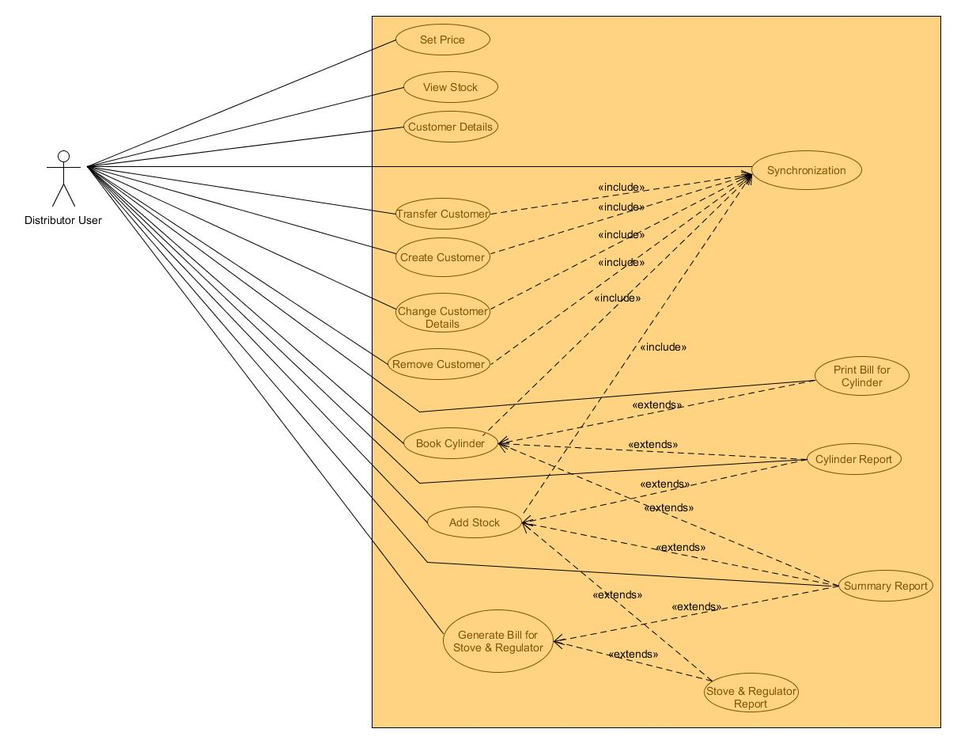**Use Case Diagrams:**
* 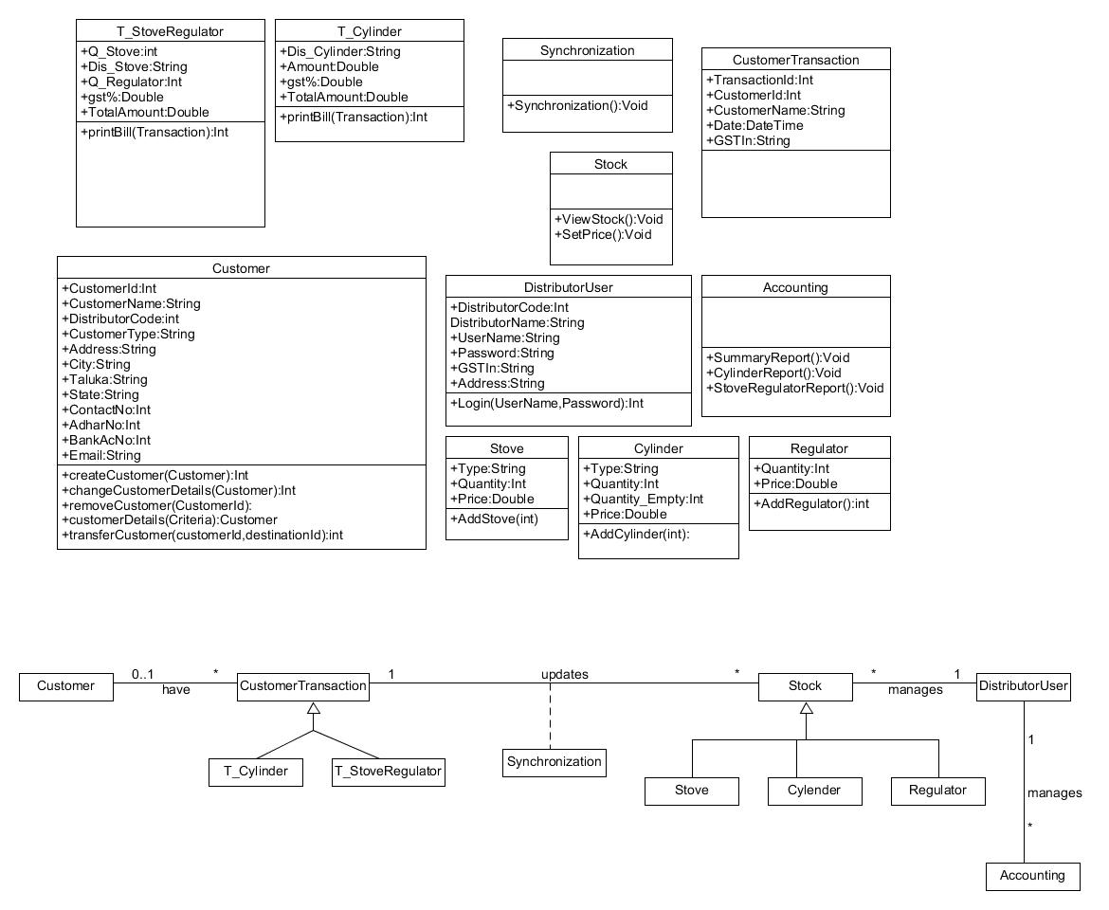**Class Diagrams:**
* 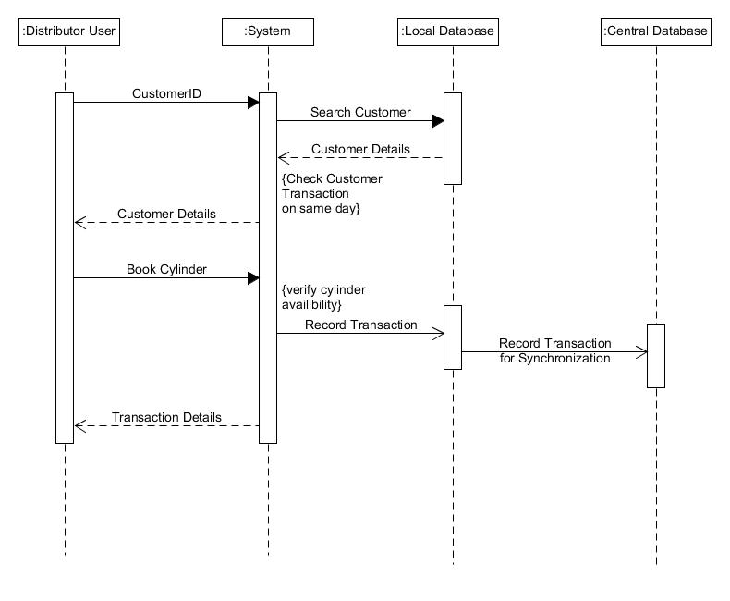**Sequence Diagrams:**
* **State Diagrams:**

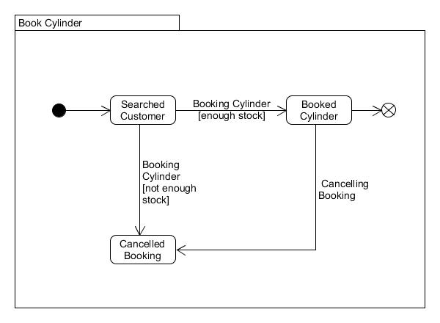

* 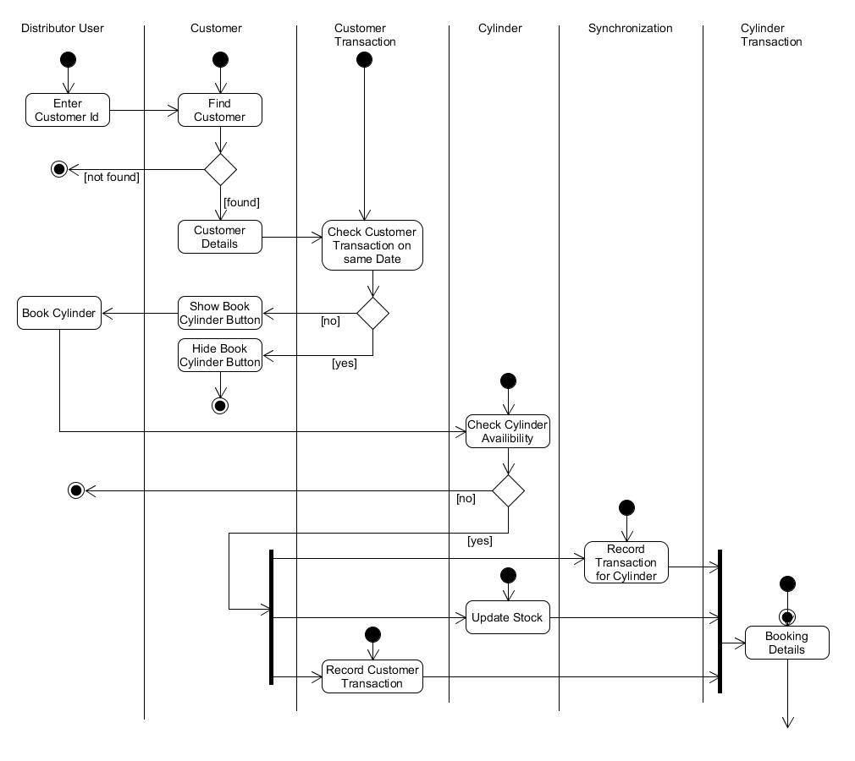**Activity Diagrams:**
* 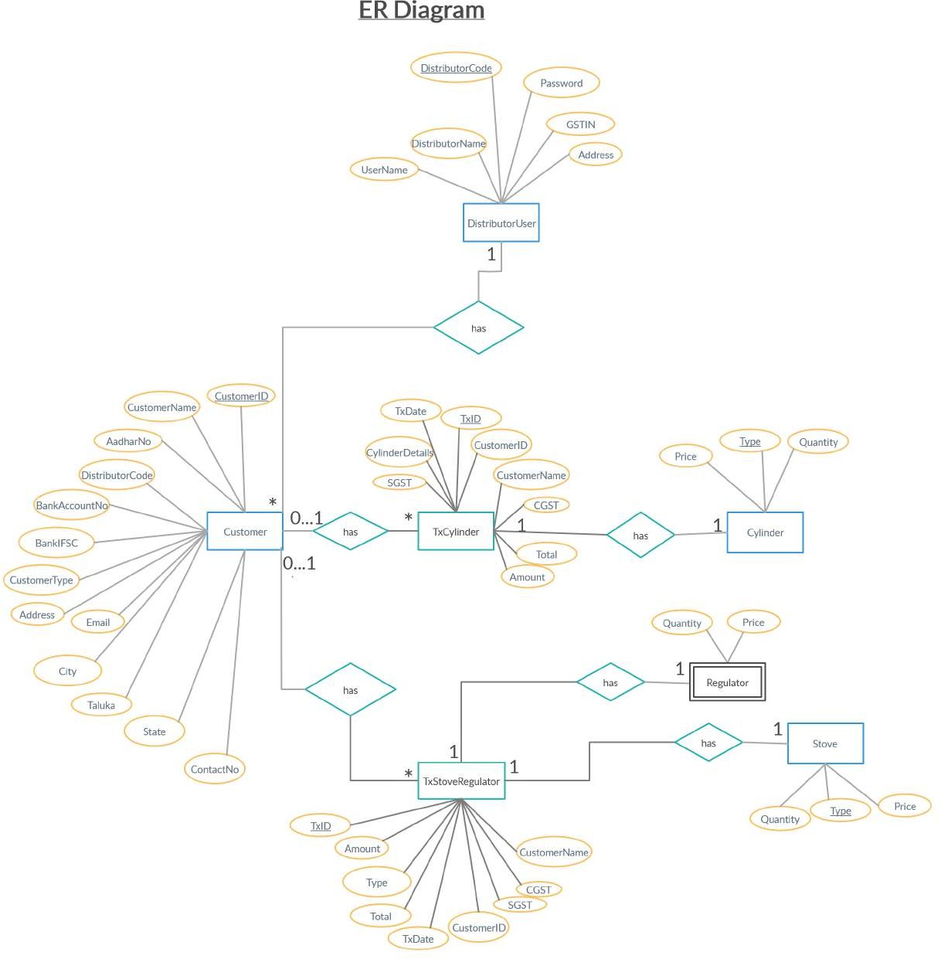**E-R Diagram:**
* **Data Dictionary:**

|  |  |  |  |  |  |  |  |
| --- | --- | --- | --- | --- | --- | --- | --- |
| **Customer** | | | | | | | |
| **Sr. No.** | **Field Name** | **Data Type** | **Width** | **Required** | **Unique** | **PK/FK** | **Referenced Table** |
| 1. | CustomerId | Int | 10 | Yes | Yes | PK |  |
| 2. | DistributorCode | Int | 6 | Yes |  | FK | DistributorUser |
| 3. | CustomerName | Varchar2 | 30 | Yes |  |  |  |
| 4. | CustomerType | Varchar2 | 10 | Yes |  |  |  |
| 5. | Address | Varchar2 | 100 | Yes |  |  |  |
| 6. | City | Varchar2 | 20 | Yes |  |  |  |
| 7. | Taluka | Varchar2 | 20 | Yes |  |  |  |
| 8. | State | Varchar2 | 20 | Yes |  |  |  |
| 9. | ContactNo | Int | 10 |  |  |  |  |
| 10. | Email | Varchar2 | 50 |  |  |  |  |
| 11. | AadharNo | Int | 12 | Yes | Yes |  |  |
| 12. | BankIFSC | Varchar2 | 15 |  |  |  |  |
| 13. | BankAccountNo | Int | 16 |  | Yes |  |  |

|  |  |  |  |  |  |  |  |
| --- | --- | --- | --- | --- | --- | --- | --- |
| **DistributorUser** | | | | | | | |
| **Sr.**  **No.** | **Field Name** | **Data Type** | **Width** | **Required** | **Unique** | **PK/FK** | **Referenced Table** |
| 1. | DistributorCode | Varchar2 | 6 | Yes | Yes | PK |  |
| 2. | DistributorName | varchar2 | 30 | Yes |  |  |  |
| 3. | Username | Varchar2 | 12 | Yes |  |  |  |
| 4. | Password | Varchar2 | 12 | Yes |  |  |  |
| 5. | GSTIN | Varchar2 |  | Yes | Yes |  |  |
| 6. | Address | Varchar2 | 100 | Yes |  |  |  |

|  |  |  |  |  |  |  |  |
| --- | --- | --- | --- | --- | --- | --- | --- |
| **Cylinder** | | | | | | | |
| **Sr. No.** | **Field Name** | **Data Type** | **Width** | **Required** | **Unique** | **PK/FK** | **Referenced Table** |
| 1. | Type | Varchar2 | 15 | Yes | Yes | PK |  |
| 2. | Quantity | Int | 5 | Yes |  |  |  |
| 3. | Price | Double |  | Yes |  |  |  |

|  |  |  |  |  |  |  |  |
| --- | --- | --- | --- | --- | --- | --- | --- |
| **Stove** | | | | | | | |
| **Sr. No.** | **Field Name** | **Data Type** | **Width** | **Required** | **Unique** | **PK/FK** | **Referenced Table** |
| 1. | Type | Varchar2 | 15 | Yes | Yes | PK |  |
| 2. | Quantity | Int | 5 | Yes |  |  |  |
| 3. | Price | Double |  | Yes |  |  |  |

|  |  |  |  |  |  |  |  |
| --- | --- | --- | --- | --- | --- | --- | --- |
| **TxCylinder** | | | | | | | |
| **Sr. No.** | **Field Name** | **Data Type** | **Width** | **Required** | **Unique** | **PK/FK** | **Referenced Table** |
| 1. | TxId | Int | 10 | Yes | Yes | PK |  |
| 2. | CustomerId | Int | 10 | Yes |  | FK | Customer |
| 3. | CustomerName | Varchar2 | 30 | Yes |  |  |  |
| 4. | TxDate | DateTime |  | Yes | Yes |  |  |
| 5. | CylinderDetails | Varchar2 | 50 | Yes |  | FK | Cylinder |
| 6. | Amount | Double |  | Yes |  |  |  |
| 7. | CGST | Double |  | Yes |  |  |  |
| 8. | SGST | Double |  | Yes |  |  |  |
| 9. | Total | Double |  | Yes |  |  |  |

|  |  |  |  |  |  |  |  |
| --- | --- | --- | --- | --- | --- | --- | --- |
| **TxStoveRegulator** | | | | | | | |
| **Sr. No.** | **Field Name** | **Data Type** | **Width** | **Required** | **Unique** | **PK/FK** | **Referenced Table** |
| 1. | TxId | Int | 10 | Yes | Yes | PK |  |
| 2. | CustomerId | Int | 10 |  |  | FK | Customer |
| 3. | CustomerName | Varchar2 | 30 |  |  |  |  |
| 4. | TxDate | DateTime |  |  | Yes |  |  |
| 5. | Details | Varchar2 | 50 | Yes |  | FK | Stove |
| 6. | Amount | Double |  | Yes |  |  |  |
| 7. | CGST | Double |  | Yes |  |  |  |
| 8. | SGST | Double |  | Yes |  |  |  |
| 9. | Total | Double |  | Yes |  |  |  |

**IMPLEMENTION DETAILS**

* Modules:-
* Customer Management Module:

Distributor User can get list of all customers by Customer Register, add new customer, change customer details and remove customer by Close Connection.

* Stock Management Module:

Distributor User can view existing stock and price, add new stock and set price of cylinder, stove and regulator.

* Synchronization Module:

Distributor User can synchronize local data ( stock and price of cylinders, customer details, customer transaction of cylinders ) to central server.

* Customer Transaction Module:

Distributor User can book cylinder for a customer and print invoice. He/ She can generate invoice for sell of stove and cylinder.

* Accounting Module:

Distributor User can get records of transections for specific period in summary or in detail and can export in excel format.

* Major Functionalities:-
* Customer Register
* Add New Customer
* Change Customer Details
* Close Connection
* Set Price for Cylinder, Stove & Regulators
* View Stock
* Add Cylinder Stock
* Add Stove & Regulator Stock
* Synchronization
* Cylinder Booking
* Bill for Stove & Regulator
* Summary Report
* Cylinder Report
* Stove & Regulator Report

**TESTING**

|  |  |  |  |
| --- | --- | --- | --- |
| EXECUTED | Passed | 13 |  |
| Failed | 0 |  |
| Total (Passed + Failed) | | 13 |
| Pending | | | 0 |
| In Process | | | 0 |
| Blocked | | | 0 |
| (Sub-Total) Total | | | 13 |

* **Black Box Testing of Individual Function :-**

Function 1 :- Customer Register

Case 1: Can’t connect to service or database

O|P: Error message will be displayed

Case 2: Connect to service and database

O|P: List of all existing customer

Function 2 :- Add New Customer

Case 1: Can’t connect to service or database

O|P: Error message will be displayed

Case 2: Connect to service and database

O|P: New customer will be added into database and customer number will be displayed.

Function 3 :- Change Customer Details

Case 1: Can’t connect to service or database

O|P: Error message will be displayed

Case 2: Connect to service and database

O|P: Customer details will be updated into database and successful message will be displayed.

Function 4 :- Close Connection

Case 1: Can’t connect to service or database

O|P: Error message will be displayed

Case 2: Connect to service and database

O|P: Customer will be deleted and successful message will be displayed.

Function 5 :- View Stock & Price

Case 1: Can’t connect to service or database

O|P: Error message will be displayed

Case 2: Connect to service and database

O|P: Stock and price of cylinder, stoves and regulator will be displayed.

Function 6 :- Set Price

Case 1: Can’t connect to service or database

O|P: Error message will be displayed

Case 2: Connect to service and database

O|P: Price of cylinder, stoves and regulator will be changed and successful message will be displayed.

Function 7 :- Add Stock

Case 1: Can’t connect to service or database

O|P: Error message will be displayed

Case 2: Connect to service and database

O|P: Stock of cylinder, stoves and regulator will be updated and successful message will be displayed.

Function 8 :- Synchronization

Case 1: Can’t connect to service or database

O|P: Error message will be displayed

Case 2: Connect to service and database

O|P: Local data (stock and price of cylinders, customer details, customer transaction of cylinders) will be synchronized with central database, last synchronization date will be changed and successful message will be displayed.

Function 9 :- Cylinder Booking

Case 1: Can’t connect to service or database

O|P: Error message will be displayed

Case 2: Connect to service and database

O|P: Booking of cylinder for that customer will be done and invoice will be generated in pdf format.

Function 10 :- Bill for Stove & Regulator

Case 1: Can’t connect to service or database

O|P: Error message will be displayed

Case 2: Connect to service and database

O|P: Bill will be generated in pdf format and successful message will be displayed.

Function 11 :- Summary Report

Case 1: Can’t connect to service or database

O|P: Error message will be displayed

Case 2: Connect to service and database, if there is at least one record of given period.

O|P: All record will be displayed of that period.

Case 3: Connect to service and database, if there is no record of given period.

O|P: Message will be displayed that “No Record Found”.

Function 12 :- Cylinder Report

Case 1: Can’t connect to service or database

O|P: Error message will be displayed

Case 2: Connect to service and database, if there is at least one record of given period.

O|P: All record will be displayed of that period.

Case 3: Connect to service and database, if there is no record of given period.

O|P: Message will be displayed that “No Record Found”.

Function 13 :- Stove & Regulator Report

Case 1: Can’t connect to service or database

O|P: Error message will be displayed

Case 2: Connect to service and database, if there is at least one record of given period.

O|P: All record will be displayed of that period.

Case 3: Connect to service and database, if there is no record of given period.

O|P: Message will be displayed that “No Record Found”.

**SCREEN-SHOTS**

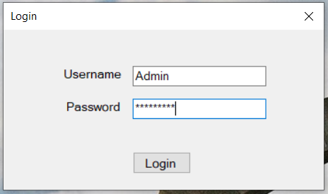

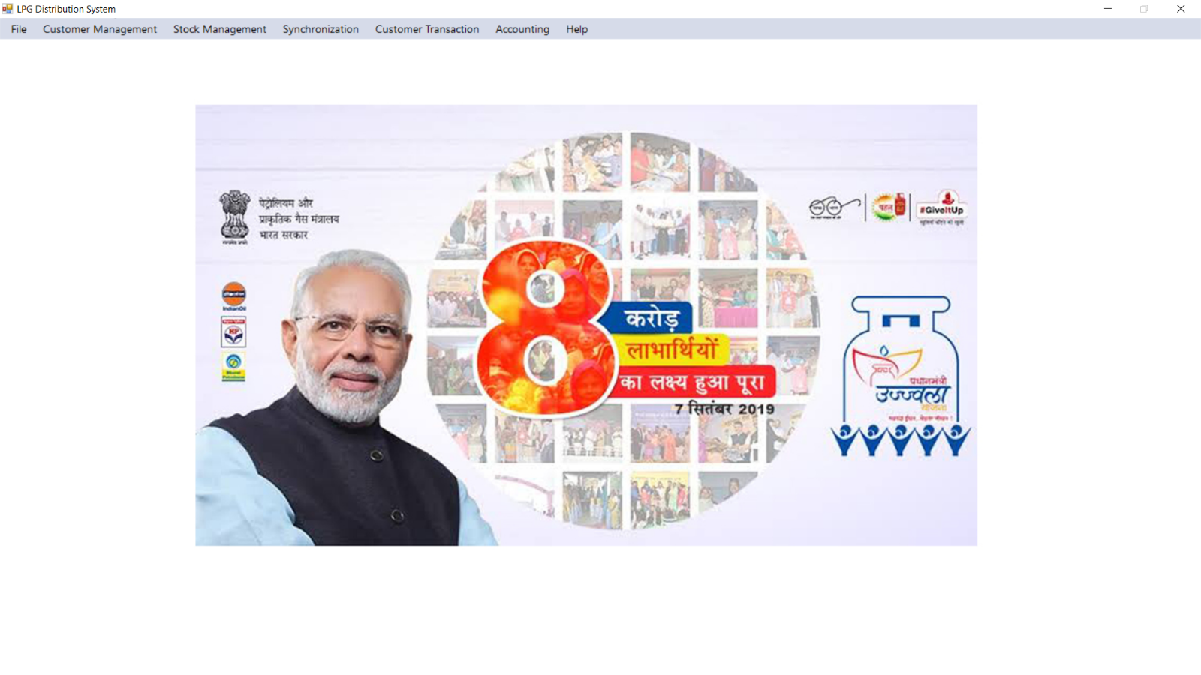

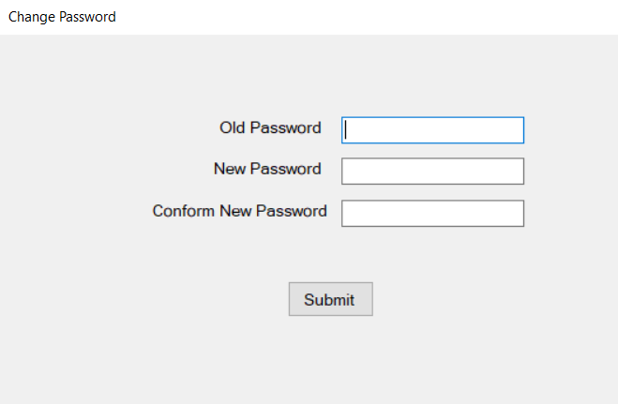

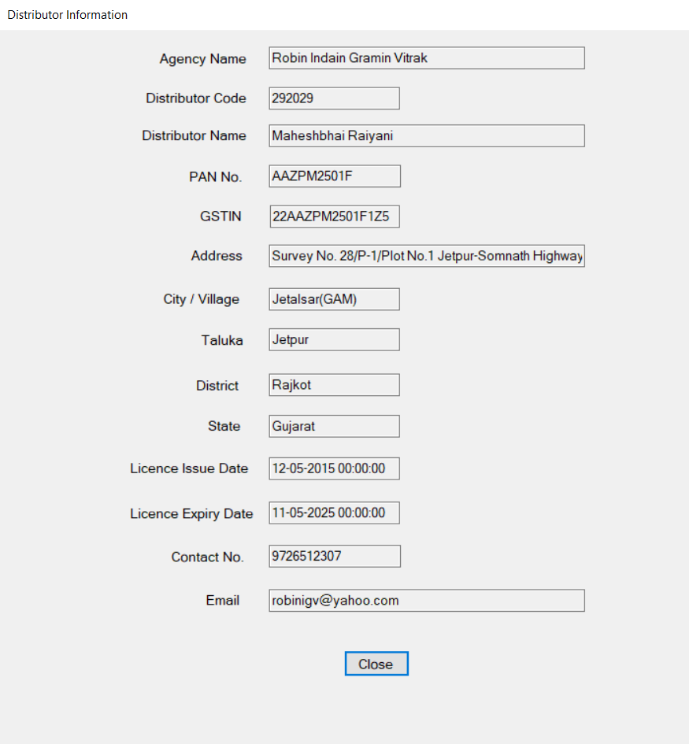

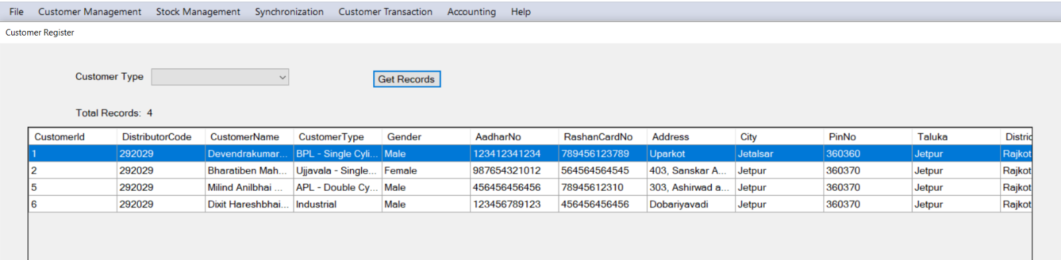

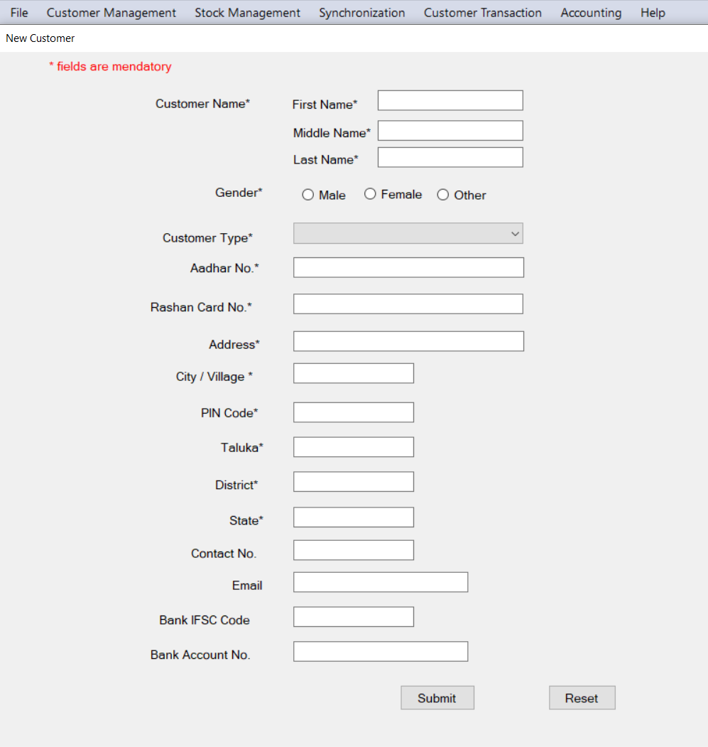

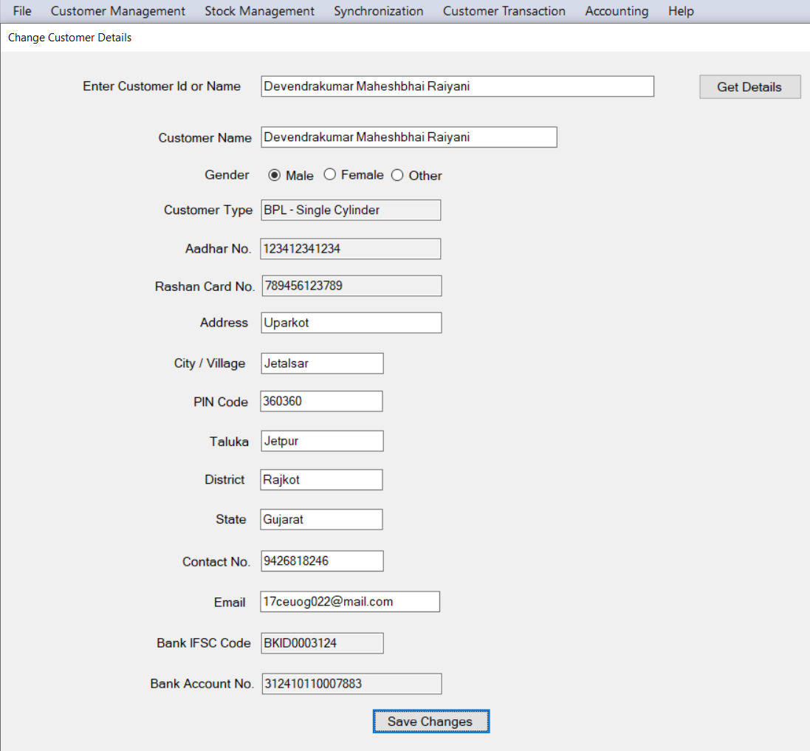

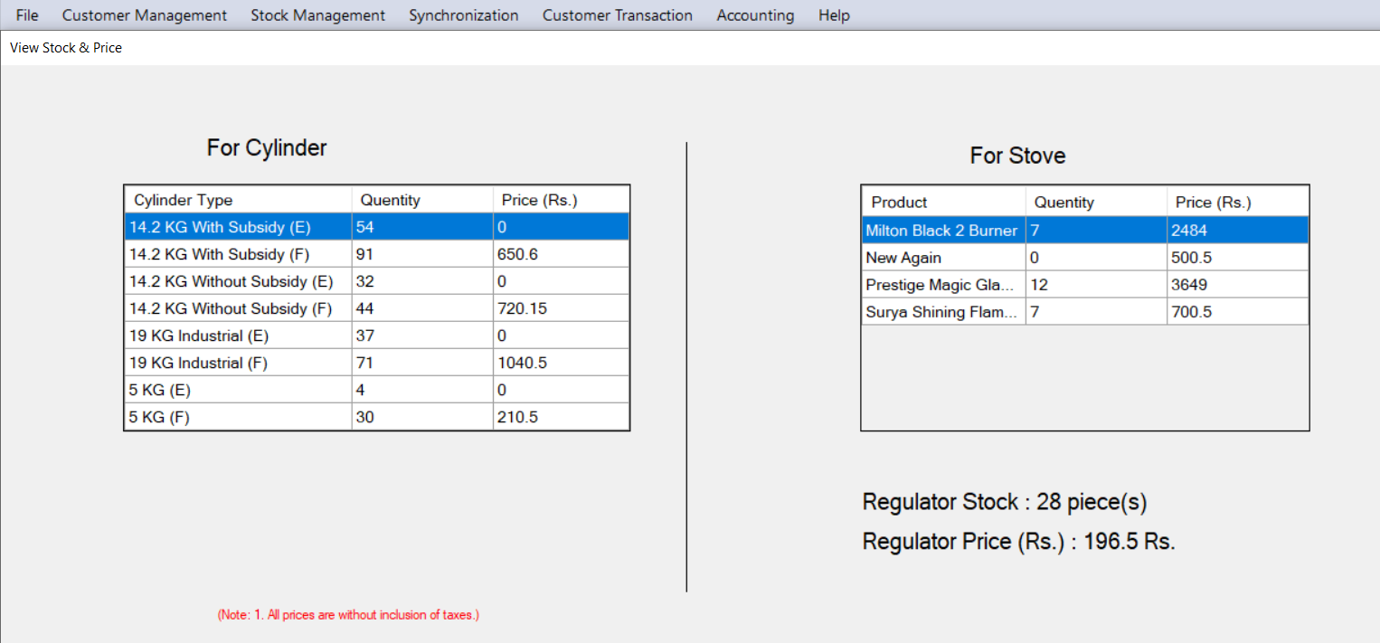

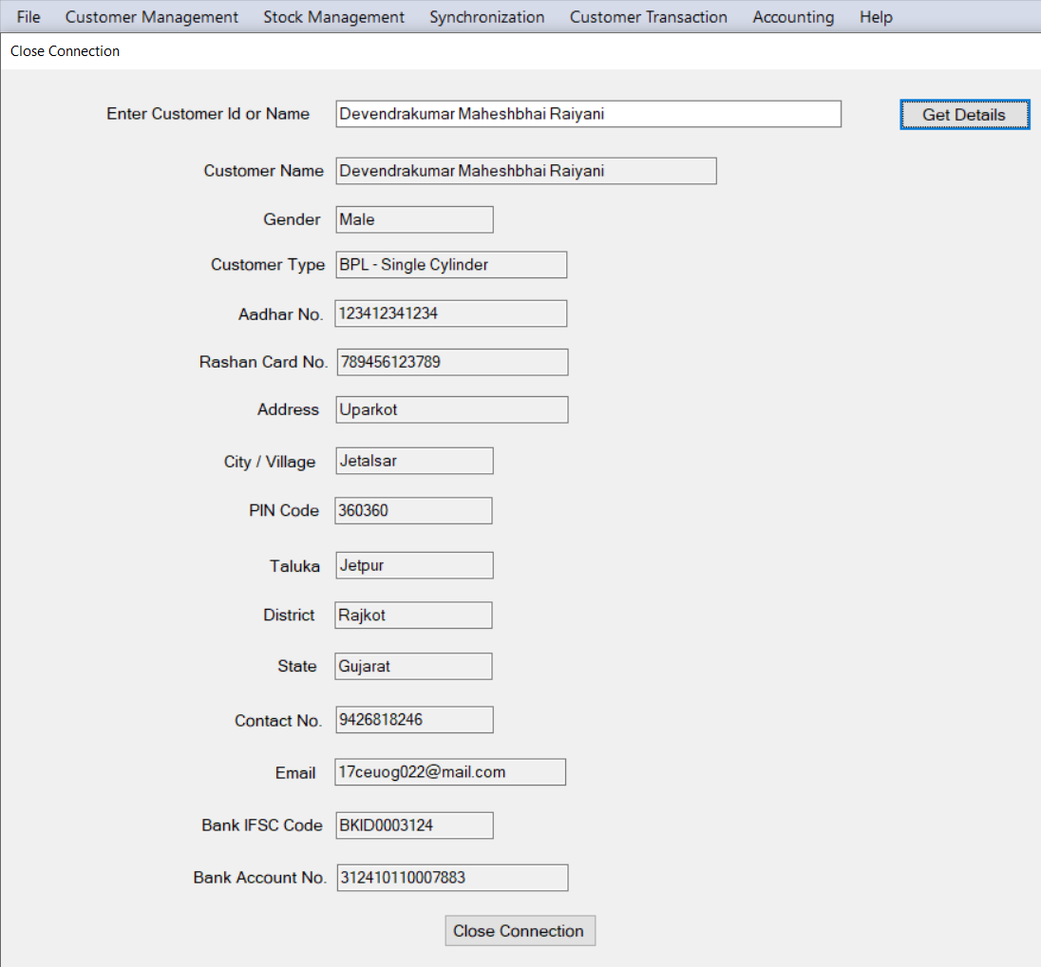

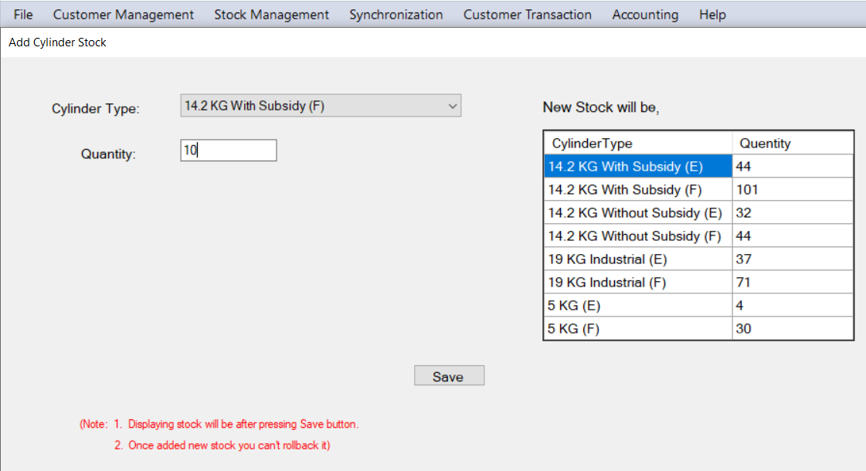

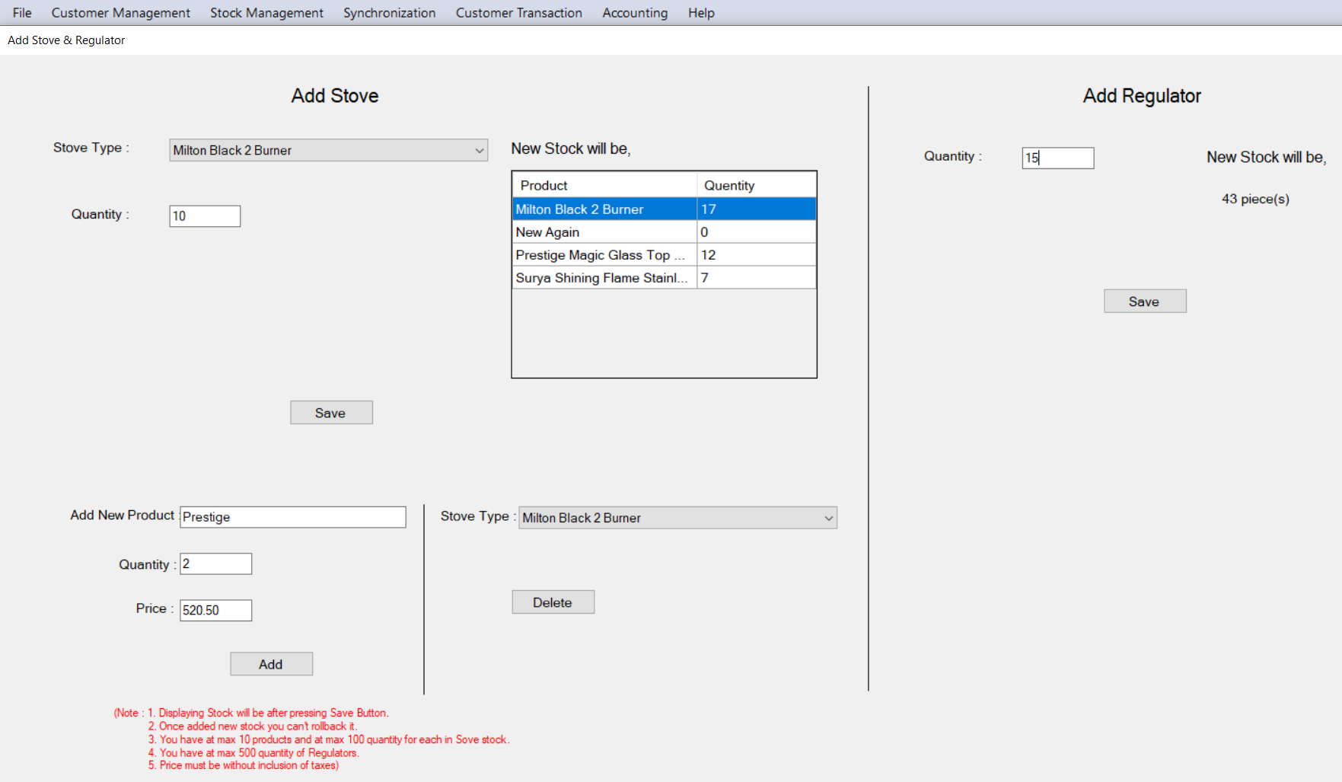

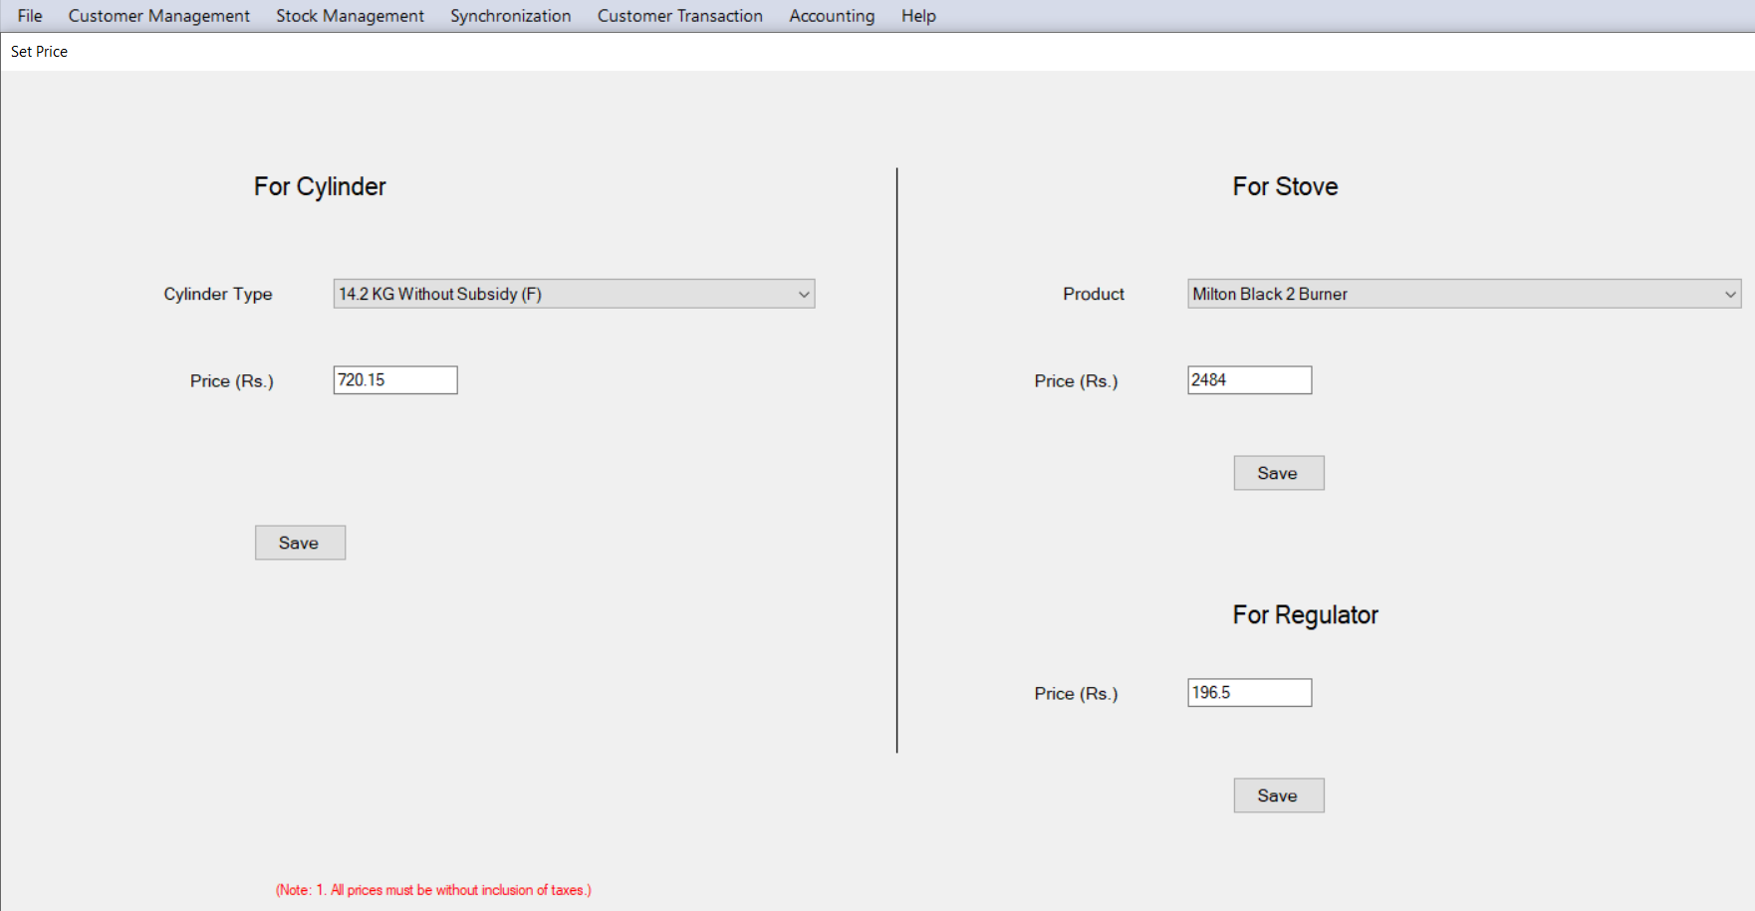

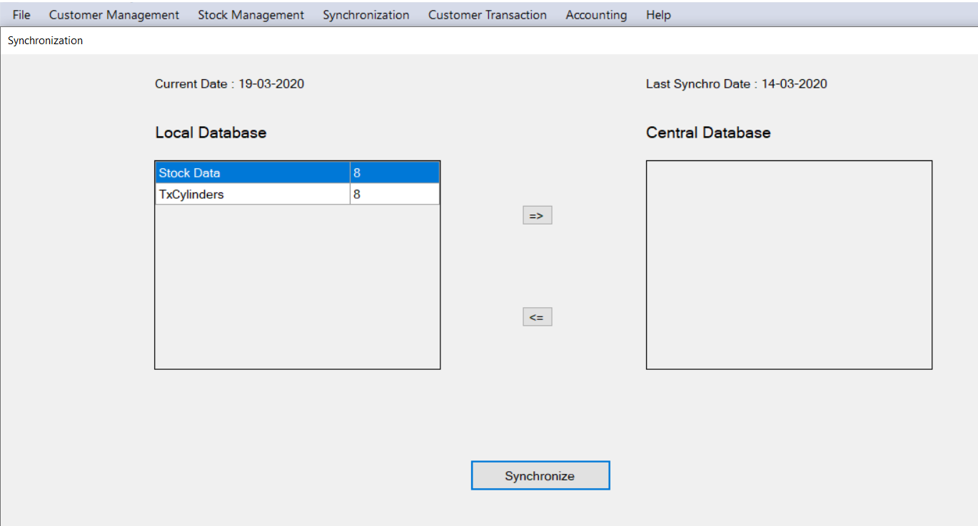

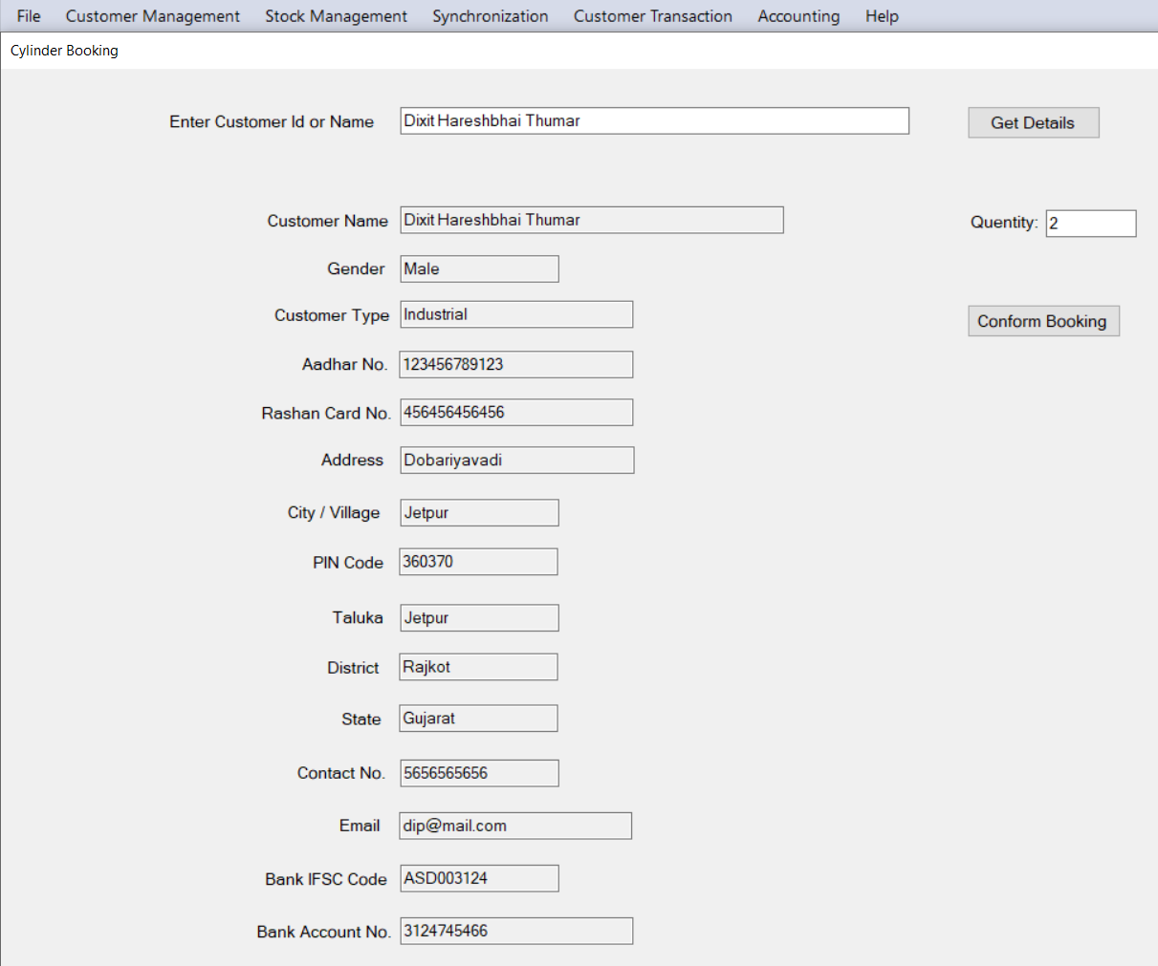

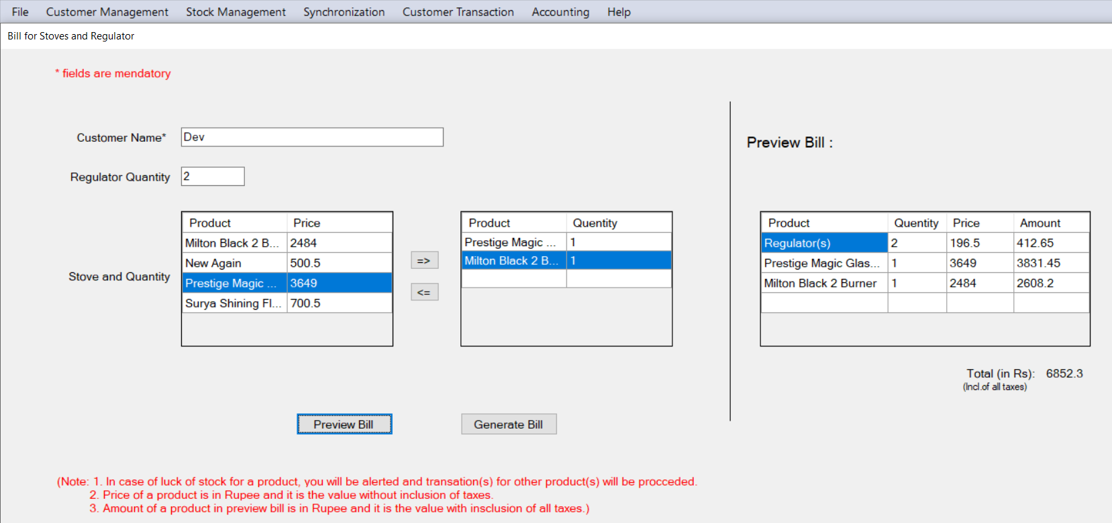

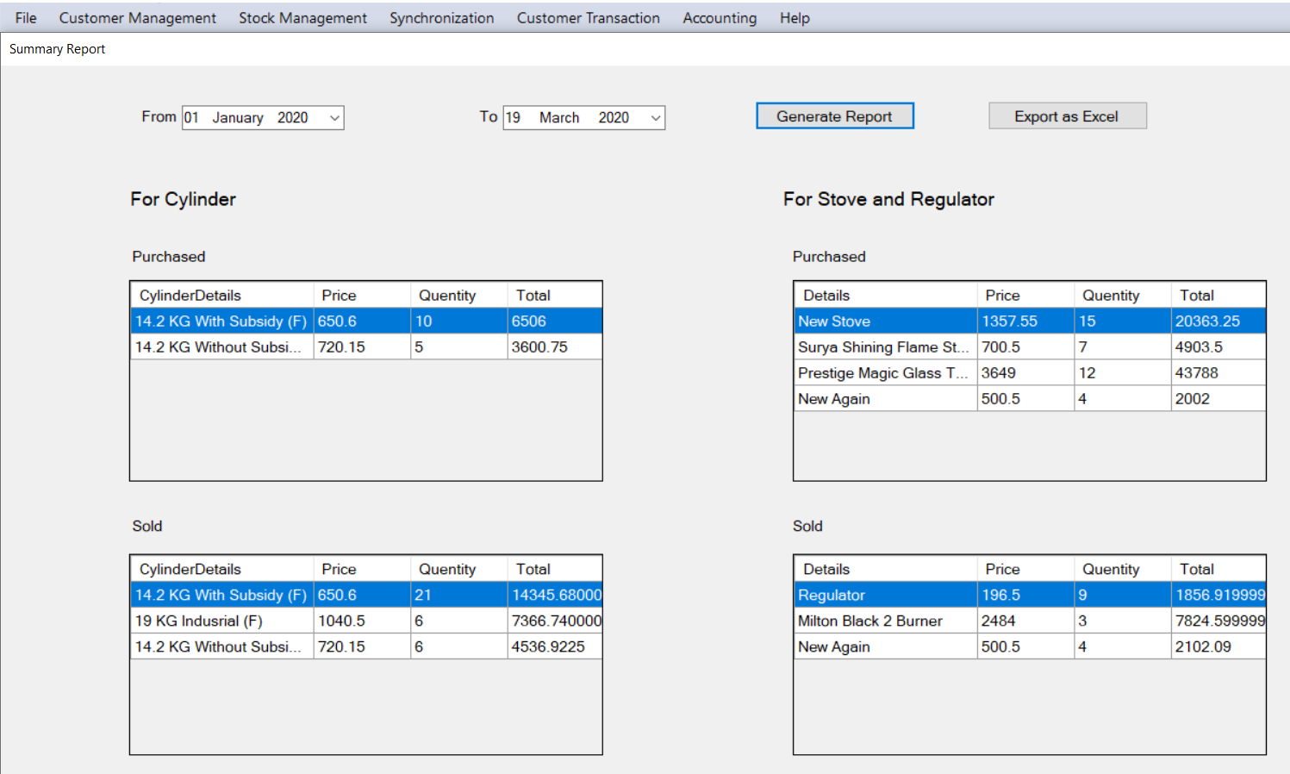

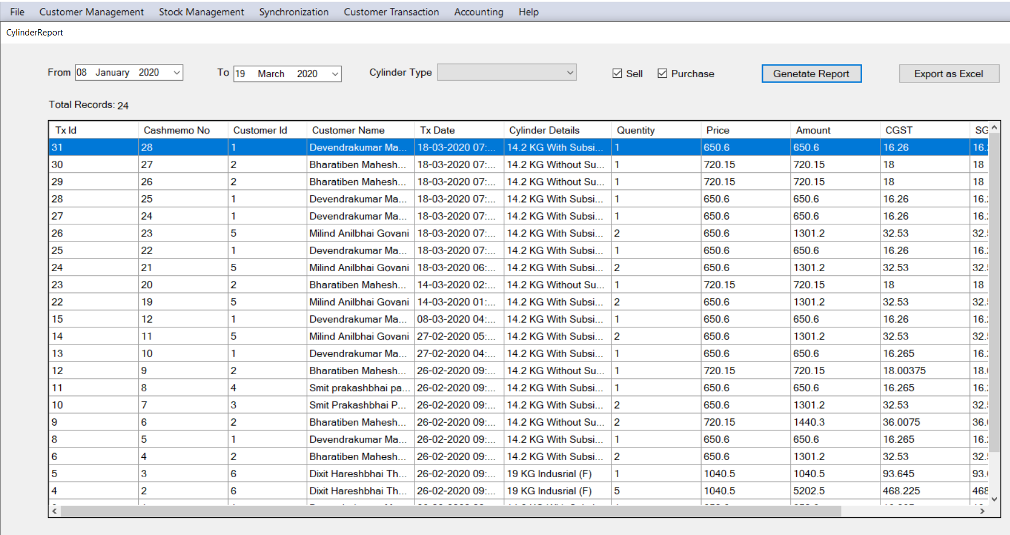

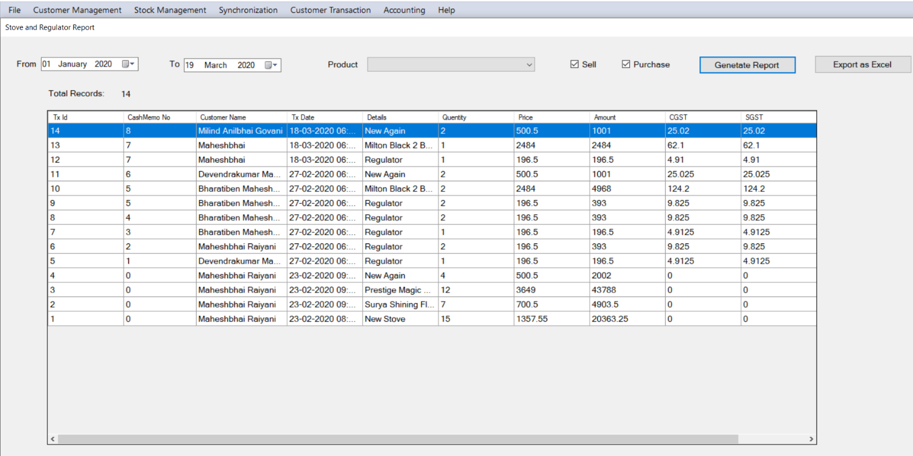

**CONCLUSION**

In this software, there is only one user that is Distributor User. Distributor User can add new customers, change existing customers’ details, close connection, get list of all existing customers as a Customer Management. He/ She can add and view stock and set prices of cylinders, stoves and regulators as a Stock Management. He/ She can book cylinder and generate invoice for existing customers and generate invoice of stove and regulator for any customer as a Customer Transactions. He/ She can get summary report, cylinder report, stove and regulator report for a given specific period. He/ She can synchronize local database with central database to send day to day work to the higher officer.

**LIMITATIONS**

***&***

**FUTURE EXTENSION**

* Limitations:

- Distributor can’t generate bulk invoice

* Not Implemented Functionalities:

- Customers of one agency can be transferred to another agency

* Future Extension:

- Distributor can generate bulk invoice

- Customers of one agency can be transferred to another agency

**BIBLIOGRAPHY**

To develop this project we have taken reference from following websites,

* StackOverflow - <https://stackoverflow.com/>
* Microsoft Documentation - <https://docs.microsoft.com/>
* C# Corner - <https://www.c-sharpcorner.com/>
* YouTube playlist of kudvenkat- <https://www.youtube.com/user/kudvenkat>